

**Experiment No.1**

**Title:**

Execution of Parallel Database queries.

# Batch: B2 Roll No.: 16010421119 Experiment No.: 1

**Aim: To execute Parallel Database queries.**

___________________________________________________________________________

# Resources needed: PostgreSQL 9.3 ___________________________________________________________________________ Theory

A parallel database system seeks to improve performance through parallelization of various operations, such as loading data, building indexes and evaluating queries. Although data may be stored in a distributed fashion, the distribution is governed solely by performance considerations. Parallel databases improve processing and input/output speeds by using multiple CPUs and disks in parallel. Centralized and client–server database systems are not powerful enough to handle such applications. In parallel processing, many operations are performed simultaneously, as opposed to serial processing, in which the computational steps are performed sequentially. Types of parallelism :

* Interquery parallelism: Execution of multiple queries in parallel

* Interoperation parallelism: Execution of single queries that may consist of more than one operations to be performed.

* Independent Parallelism - Execution of each operation individually in different  processors only if they can be executed independent of each other. For

  example, if we need to join four tables, then two can be joined at one processor and the other two can be joined at another processor. Final join can be done later.

* Pipe-lined parallelism - Execution of different operations in pipe-lined  fashion. For example, if we need to join three tables, one processor may join

  two tables and send the result set records as and when they are produced to the other processor. In the other processor the third table can be joined with the   incoming records and the final result can be produced.

• Intraoperation parallelism Execution of single complex or large operations in parallel in multiple processors. For example, ORDER BY clause of a query that tries to execute on millions of records can be parallelized on multiple processors.

# ___________________________________________________________________________

**Procedure:**

**Parallel queries provide parallel execution of sequential scans, joins, and aggregates etc.**

Parallel queries provide parallel execution of sequential scans, joins, and aggregates. To make the performance gains need a lot of data.

create table ledger (

id serial primary key,

date date not null,

amount decimal(12,2) not null

);

insert into ledger (date, amount)

select current_date - (random() * 3650)::integer, (random() * 1000000)::decimal(12,2) - 50000 from generate_series(1,50000000);

# explain analyze select sum(amount) from ledger;

Reading the output, we can see that Postgres has chosen to run this query sequentially. Parallel queries are not enabled by default. To turn them on, we need to increase a config param called max_parallel_workers_per_gather.

**show max_parallel_workers_per_gather;**

Let’s raise it to four, which happens to be the number of cores on this workstation.

# set max_parallel_workers_per_gather to 4;

Explaining the query again, we can see that Postgres is now choosing a parallel query. And it’s about four times faster.

# explain analyze select sum(amount) from ledger;

**The planner does not always consider a parallel sequential scan to be the best option. If a query is not selective enough and there are many tuples to transfer from worker to worker, it may prefer a “classic” sequential scan.PostgreSQL optimises the number of workers according to size of the table and the min_parallel_relation_size.**

Similar ways we can execute join operation and check parallel execution of sequential join.

# explain analyse select library1.id,library1.quantity,library2.location from library2,library1 where library1.id=library2.id; SET max_parallel_workers_per_gather TO 3; explain analyse select library1.id,library1.quantity,library2.location from library2,library1 where library1.id=library2.id;

**___________________________________________________________________________ Questions:**

1. Explain the parallelism achieved in the experiment you performed.

Ans –

Components of a task, such as a database query, can be run in parallel to dramatically enhance performance. The nature of the task, the database configuration, and the hardware environment, all determine how the database product will perform a task in parallel.

These factors are interrelated. Consider them all when you work on the physical and logical design of a database. The following types of parallelism are supported by the Db2 database system:

1. With comparison of the results explain how degree of parallelism ( no of parallel processors) affect the operation conducted.

Ans –

As the number of Parallel Workers increase the query time for any particular query decreases.

# ___________________________________________________________________________ Results: (Program printout with output)

**CODE:-**

**-- Creating Table Ledger**

**create table ledger**

**(**

**id serial primary key,**

**date date not null,**

**amount decimal(12,2) not null**

**);**

**-- Generating values for 500000000 values**

**insert into ledger (date, amount)**

**select current_date - (random() * 3650)::integer, (random() * 1000000)::decimal(12,2) -**

**50000 from generate_series(1,50000000);**

**select * from ledger;**

**-- Analyzing the query**

**explain analyze select sum(amount) from ledger;**

**-- Checking the maximum parallel workers**

**show max_parallel_workers_per_gather;**

**-- Setting new value for maximum parallel workers**

**set max_parallel_workers_per_gather to 4;**

**explain analyze select sum(amount) from ledger;**

**Outputs :-**

1. Viewing all 50000000 rows after inserting them..

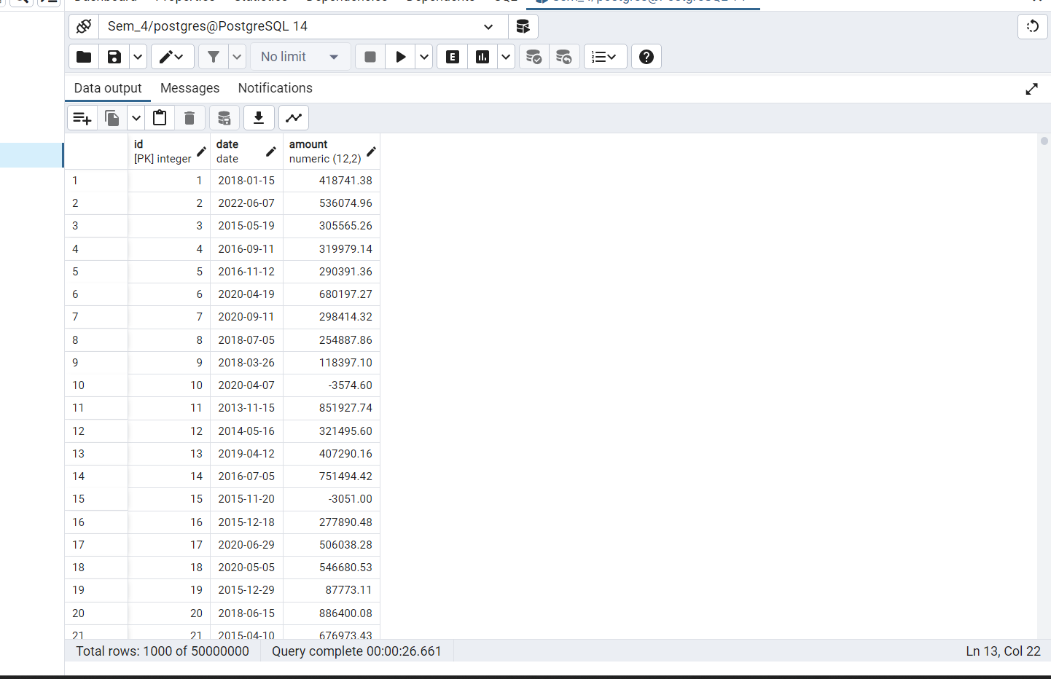

1. Analyzing the Query….

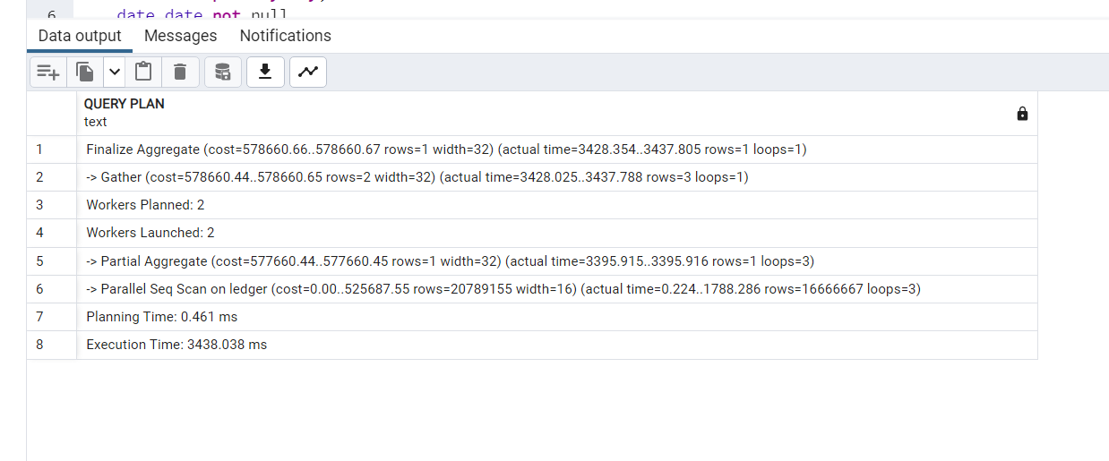

1. Maximum Parallel Workers (Default)

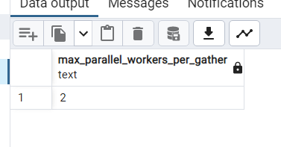

1. Setting new value for Max parallel Workers

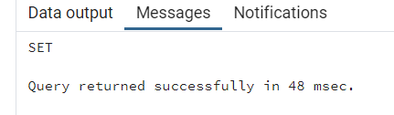

1. Reviewing the Max parallel Workers

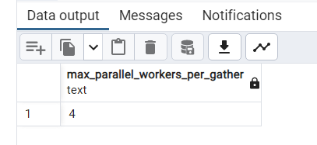

1. Change in the Query Plan After change in Max parallel Workers

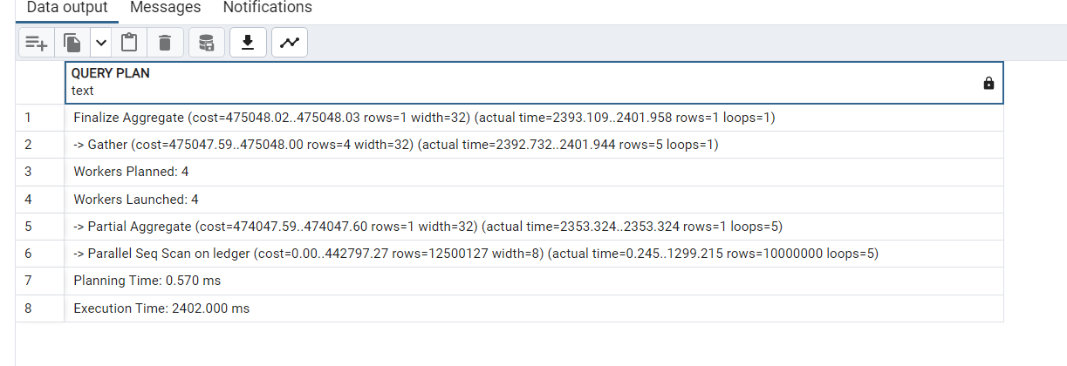

___________________________________________________________________________ **Outcomes:**

**CO 1. Design advanced database systems using Parallel, Distributed and In-memory databases and its implementation.**

**Conclusion: (Conclusion to be based on the outcomes achieved)**

# We have learnt how to execute Parallel Database queries.



**Grade: AA / AB / BB / BC / CC / CD /DD**

**Signature of faculty in**

**-**

**charge with date**

**___________________________________________________________________________**

**References:**

**Books/ Journals/ Websites:**

1.

Elmasri and Navathe, “Fund

amentals of Database Systems”, Pearson Education

2.

https://www.postgresql.org/docs/